**Assignment 1 : Simple SQL Query with a single table with where clause.**

**Write a query to get a Product list (id, name, unit price) where current products cost less than $20.**

**:-**

select ProductID as ID, ProductName as Name, UnitPrice as Price from Products

where UnitPrice < 20;

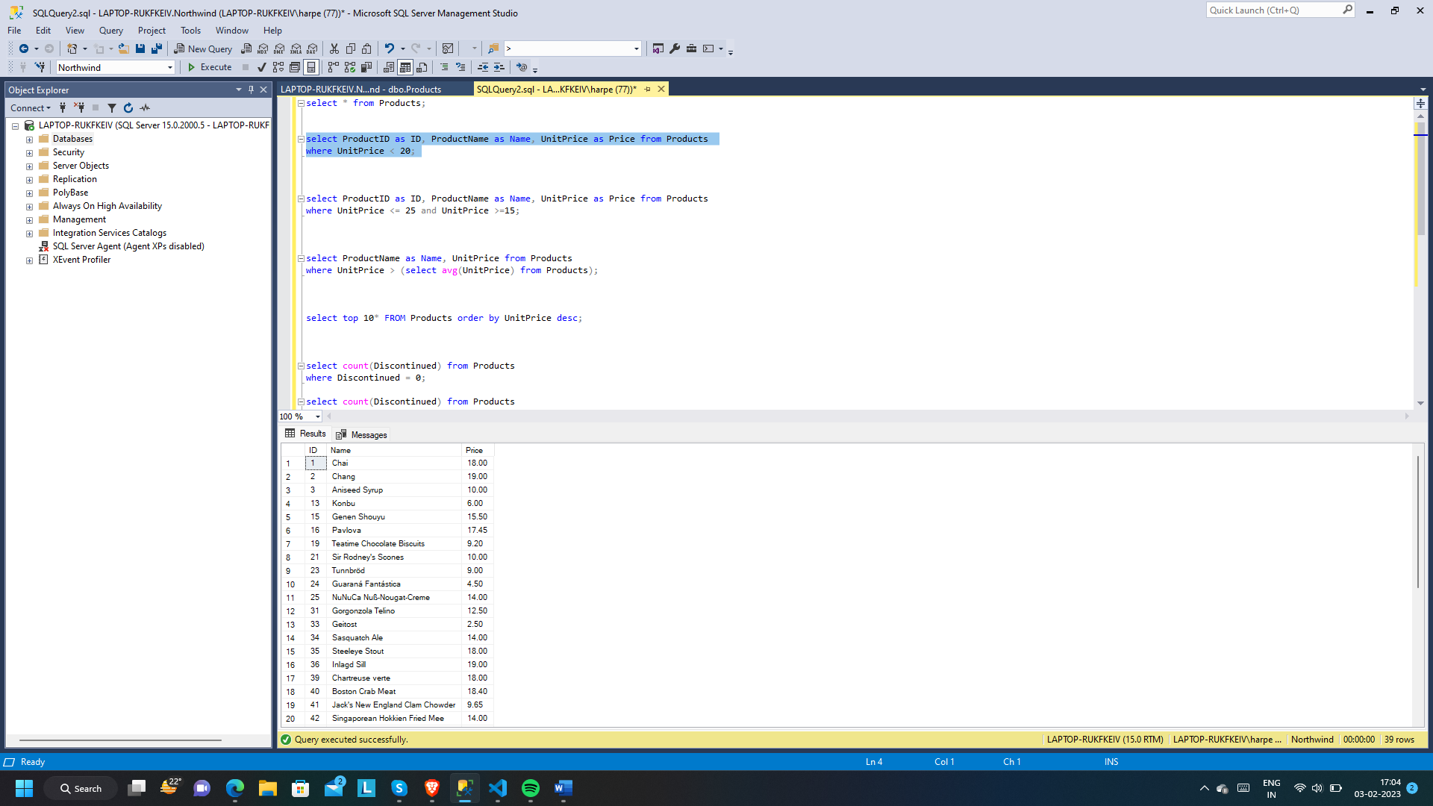

**Write a query to get Product list (id, name, unit price) where products cost between $15 and $25.**

:-

select ProductID as ID, ProductName as Name, UnitPrice as Price from Products

where UnitPrice <= 25 and UnitPrice >=15;

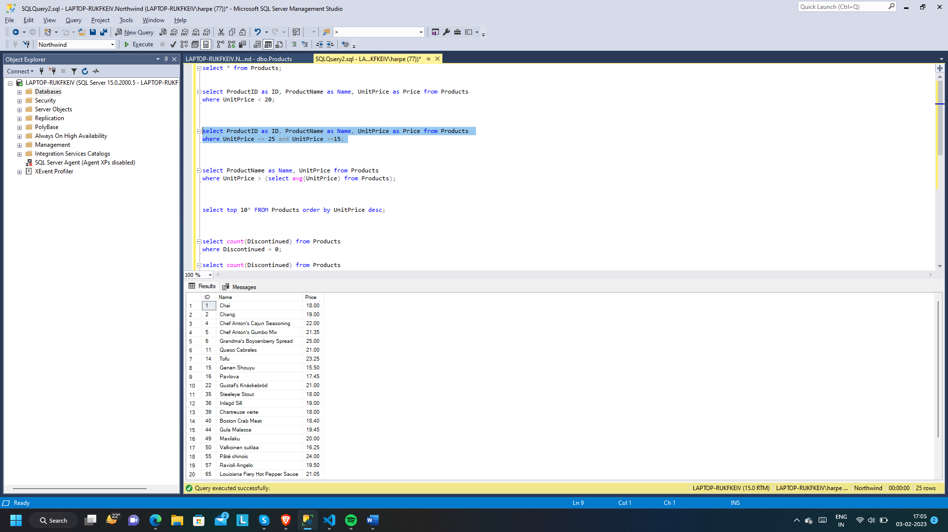

**Write a query to get Product list (name, unit price) of above average price.**

**:-**

select ProductName as Name, UnitPrice from Products

where UnitPrice > (select avg(UnitPrice) from Products);

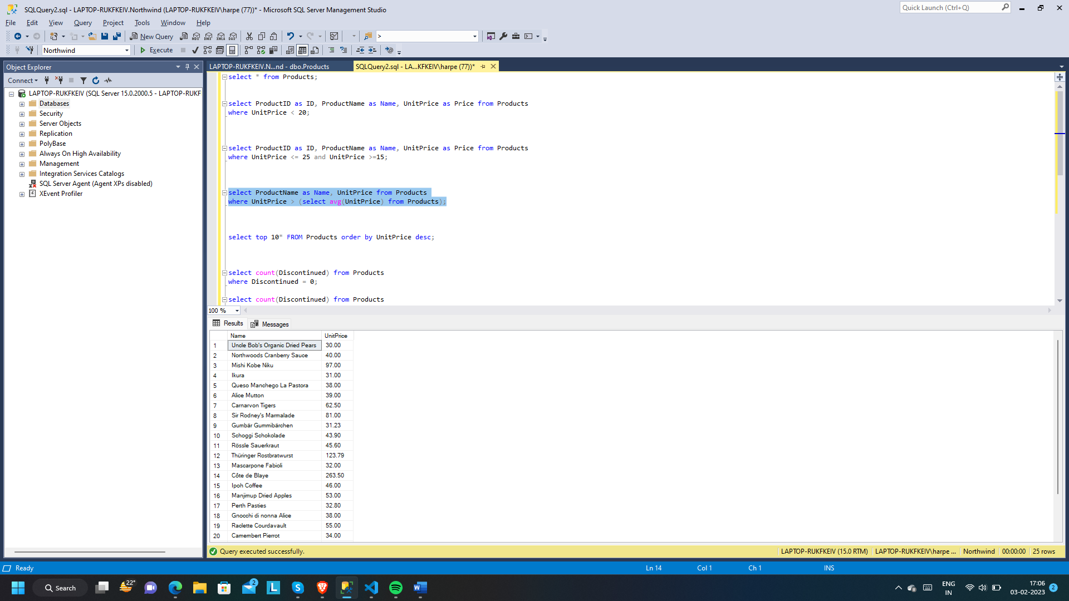

**Write a query to get Product list (name, unit price) of ten most expensive products.**

**:-**

select top 10* FROM Products order by UnitPrice desc;

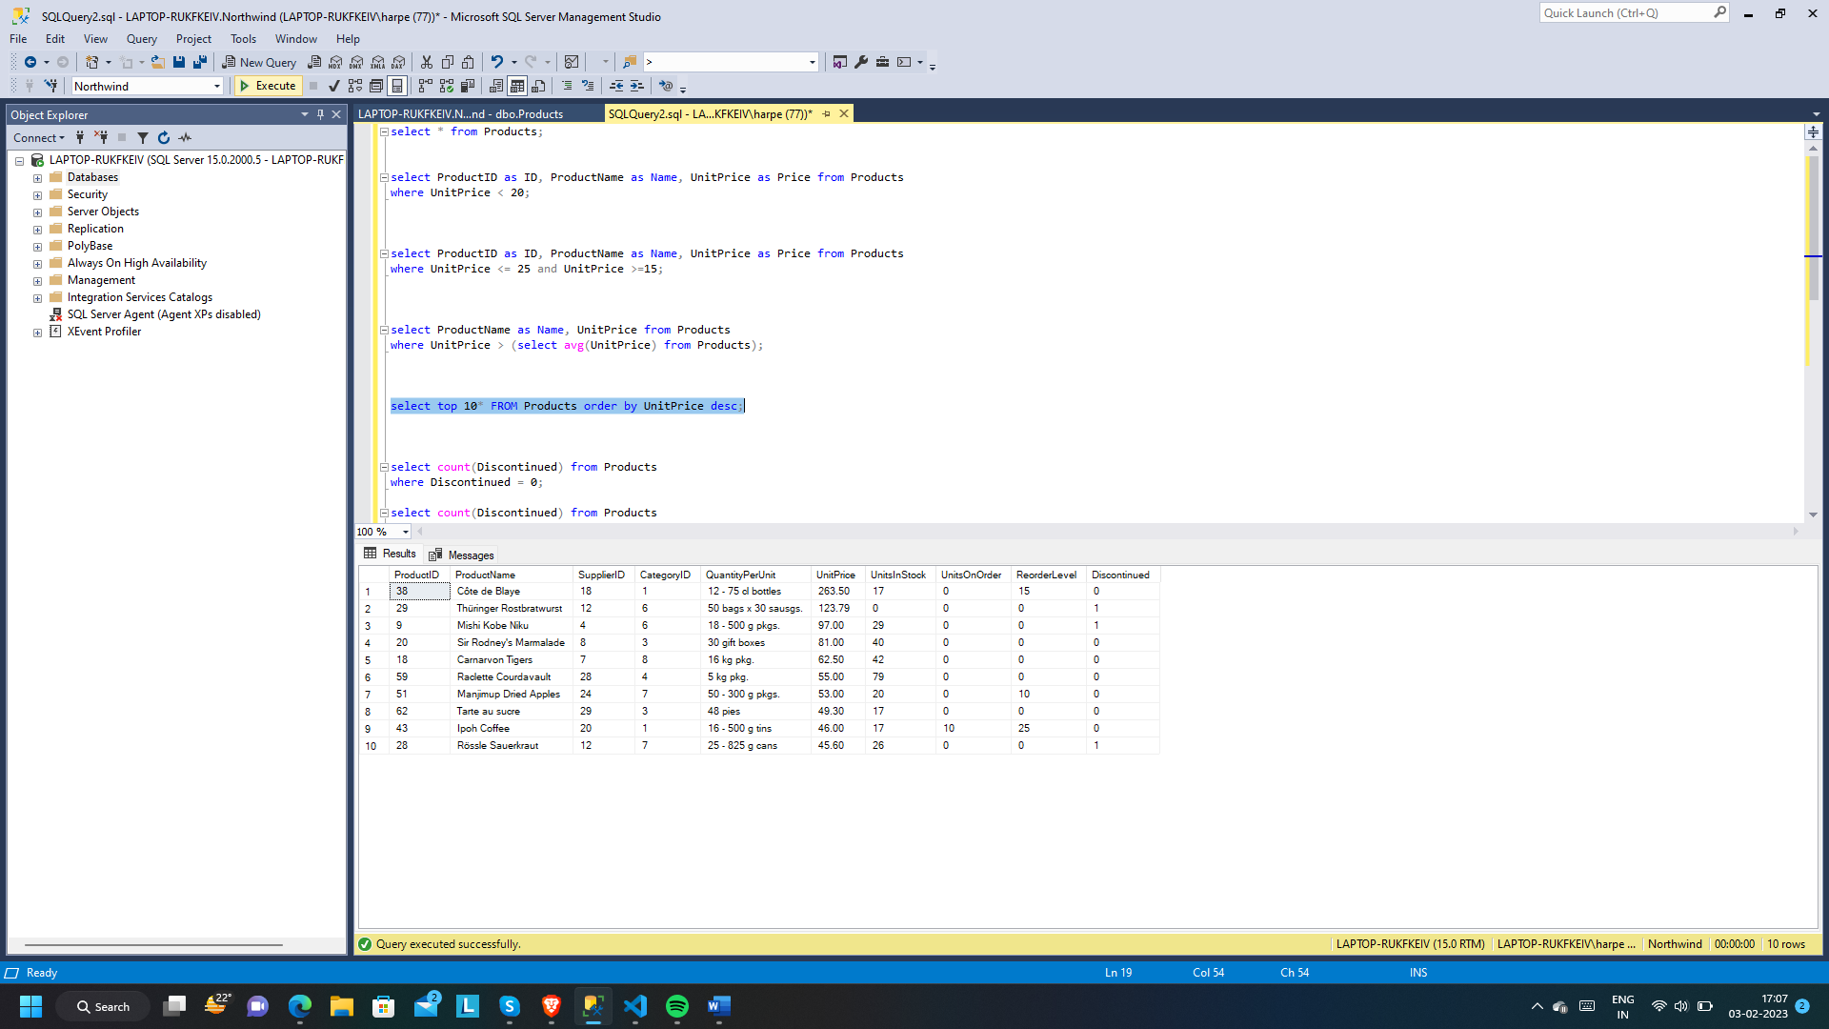

**Write a query to count current and discontinued products.**

**:-**

select count(Discontinued) from Products

where Discontinued = 0;

select count(Discontinued) from Products

where Discontinued = 1;

select Discontinued, count(Discontinued) as TotalDoscontinued from Products

Group By Discontinued;

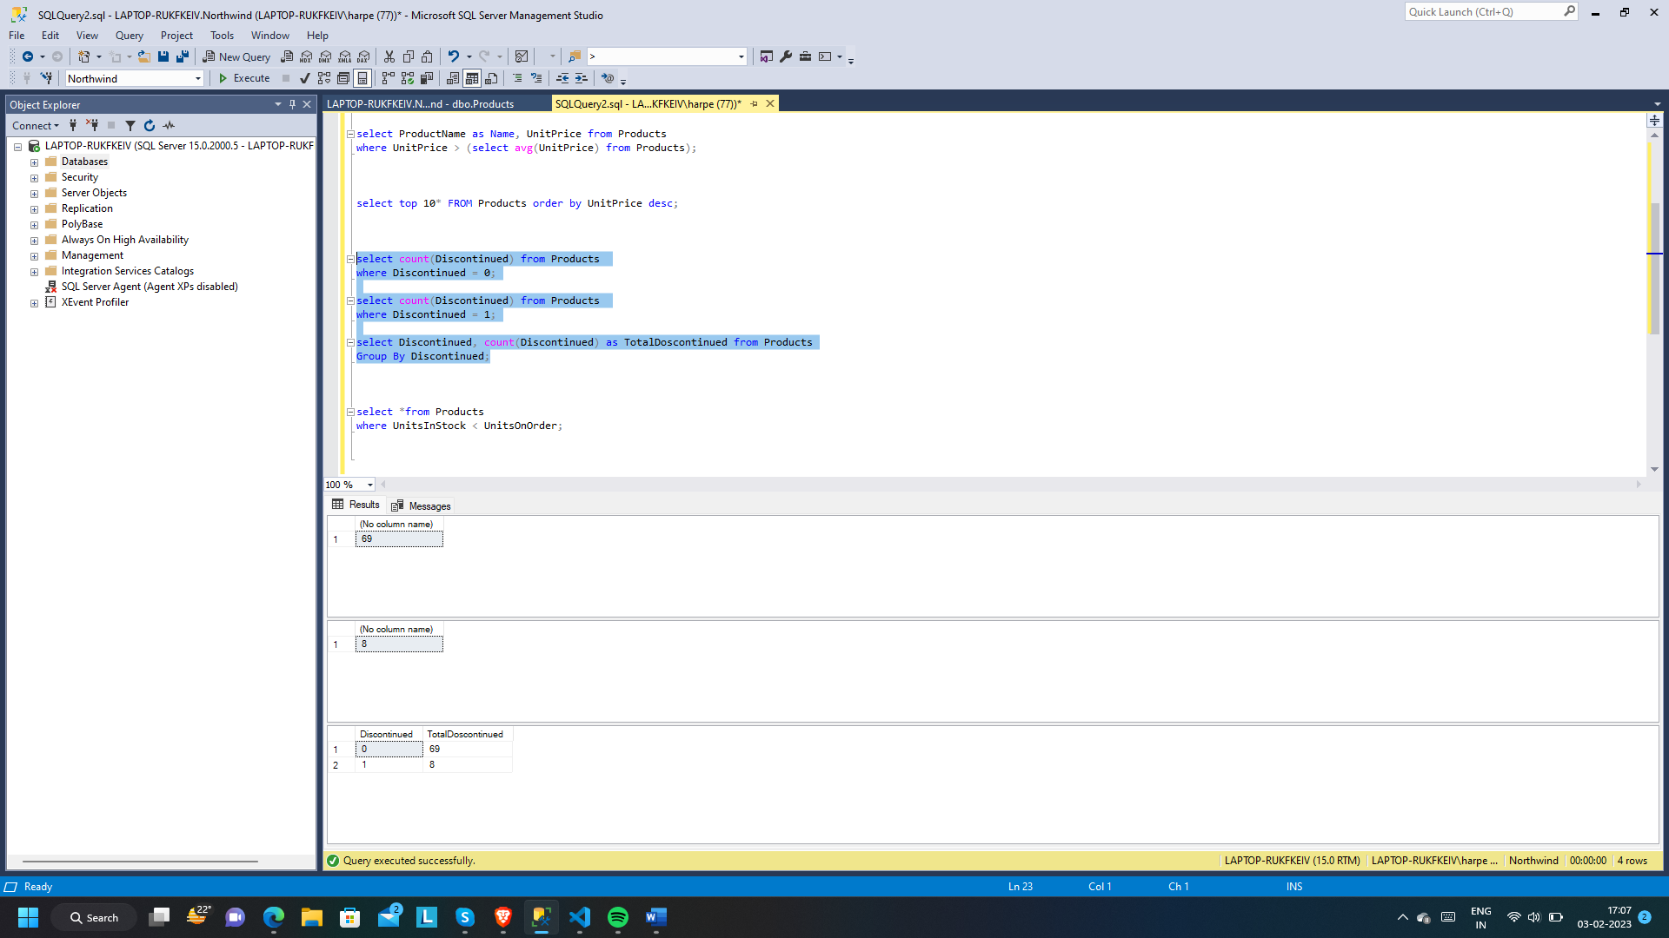

**Write a query to get Product list (name, units on order , units in stock) of stock is less than the quantity on order.**

**:-**

select *from Products

where UnitsInStock < UnitsOnOrder;

